PHENIKAA UNIVERSITY
PHENIKAA INFORMATION TECHNOLOGY SCHOOL


Course Name: Software Architecture

Project Title: Library Management System using Layered Architecture and CQRS (Domain Events)

Student Info : Nguyễn Thành Vinh (23010365 – K17-KTPM)

Hà Nội, tháng 02 năm 2026
Table of Contents
• Overall Model: Client-Server (RESTful API) 1
• Backend Architecture (.NET 8) 1
• Frontend Architecture (ReactJS) 3
• Data Flow Example: "Borrowing a Book" 3
• System Overview 3
• Completed Features 4
A. Member Module (User: vinh09) 4
B. Administrative Module (User: admin) 4
• Real-world Data Flow 5
• UI/UX Design 5
1. Authentication & Authorization 6
2. Book Management 6
3. Borrowing Process 6
4. Returning Process 7
5. Member Management 7
6. Dashboard & Analytics 7
7. User Catalog (Book Search) 8
1. Security 8
2. Data Integrity & Reliability 8
3. Performance 9
4. Maintainability & Scalability 9
5. Interoperability 9
6. Usability (Frontend focus) 10
ASR-01: Modifiability & Separation of Concerns 10
ASR-02: Stateless Security Mechanism 10
ASR-03: Data Consistency in Complex Transactions 11
ASR-04: Media Performance Optimization 11
System Context Diagram (C4 Model - Context Level) 13
1. Actors 13
2. Main Context (Software System) 14
3. External Systems 14
4. Data Flows & Interactions 14
Container Diagram (C4 Model - Container Level) 15
1. Architectural Overview 15
2. Detailed Container Analysis 16
3. Interaction with External Systems 16
4. Communication Protocols & Data Flow 16
Component Diagram (C4 Model - Component Level) 17
1. Presentation Layer (Controllers) 18
2. Business Logic Layer (Services) 18
3. Data Access Layer (Repositories) 18
4. Typical Interaction Flow (Example: Borrowing a Book) 18
System Architecture 20
1. Presentation Layer 20
2. Business Logic Layer (BLL) 20
3. Data Access Layer (DAL) 20
4. Data Flow 21
III. CONCLUSION & FUTURE DEVELOPMENT 24
1. Lessons Learned 24
2. Future Improvements 24

- Executive Summary
- The goal of this project is to design and implement a modern Library Management System (LMS) that supports the management of physical books, audiobooks, members, and borrowing/returning workflows. The core architectural pattern utilized is Layered Architecture combined with the Repository Pattern and Domain Events (via MediatR) to ensure separation of concerns, maintainability, and scalability. The final achievement is a complete full-stack system with a robust .NET Core Backend and a user-friendly React Frontend, meeting complex business requirements such as automatic fine calculation and large file uploading (chunking).
- The project is built using an N-Layer Architecture combined with a Decoupled Client-Server model. Additionally, the Backend incorporates principles of Domain-Driven Design (DDD) and Event-Driven Architecture at a lightweight level.

Overall Model: Client-Server (RESTful API)
  - The system is divided into two completely separate entities communicating via HTTP/HTTPS (RESTful API):
  - Frontend (Client): Runs on the user's browser (ReactJS), responsible for rendering the UI and making API calls.
  - Backend (Server): Runs on the server (.NET 8), responsible for processing business logic, security, and data retrieval.

Backend Architecture (.NET 8)
  - The Backend is organized into a 3-Tier/Layered Architecture integrated with the Repository Pattern.

Core Layers:
- Presentation Layer (API Controllers):
  - Location: Controllers folder (e.g., BookController.cs).
  - Responsibilities: Receives HTTP requests, handles Authentication/Authorization (JWT), validates input data (FluentValidation), and returns JSON responses.
- Business Logic Layer (Service Layer):
  - Location: Service folder.
  - Responsibilities: Contains core business logic (e.g., checking stock availability before borrowing). It uses AutoMapper for DTO-Entity conversion and MediatR to trigger Domain Events (e.g., BorrowEvent), decoupling complex logic like inventory updates.
- Data Access Layer (Repository):
  - Location: Repository folder.
  - Responsibilities: Directly interacts with the database via Entity Framework Core (DBContext) and provides CRUD methods, hiding LINQ/SQL complexity from the Service layer.
- Concept (Khái niệm): The Catalog Service owns all data related to books (Books), audio (Audios), and book history (BookHistories).
- Implementation (Triển khai): In the source code, this is demonstrated by the BookRepository being the only component authorized to query these specific database tables directly. Other services (such as the Lending Service) must call the Catalog Service's API to retrieve book information and are strictly prohibited from accessing its database directly.
- Domain/Data Layer:
  - Location: Models, Domain, Data folders.
  - Responsibilities: Defines entity classes (e.g., Book, User) and database configurations.
Layer | Primary Function | Input | Output | Artifact (Implementation)
Presentation | Processes HTTP API requests and manages data flow navigation. | HTTP Request (JSON from Client) | HTTP Response (Status Code, JSON) | BookController, AuthController
Business Logic | Executes business rules (late fees, stock checks) and data validation. | DTO (Data Transfer Object) | Validated Model Object | BookService, BorrowSlipService
Persistence | Maps objects to the DB and performs basic CRUD operations. | ORM Command (LINQ, Entity Framework) | Database Record / Tuple | BookRepository, MemberRepository

Design Patterns Used:
- Dependency Injection (DI): Decouples code for better maintainability.
- Repository Pattern: Segregates data access logic.
- Mediator Pattern: Uses MediatR to handle events (BorrowEventHandler), reducing direct dependencies between services.

Frontend Architecture (ReactJS)
The Frontend is a Single Page Application (SPA) built with Vite.
- Component-Based: UI is divided into reusable components (e.g., BookCard, Sidebar).
- State Management: Uses useState, useEffect, and Context API for application state.
- Routing: Managed by react-router-dom for seamless navigation.
- API Client: Uses Axios with Interceptors to automatically attach JWT Tokens to headers.

Data Flow Example: "Borrowing a Book"
- Frontend: User clicks "Borrow Now" UserCatalog.jsx calls POST /api/borrow-slips.
- API Layer: BorrowSlipController receives the request and verifies the Token.
- Service Layer: BorrowSlipService validates the User and Stock, initiates a Transaction, and saves the slip via BorrowSlipRepository.
- Event: A BorrowEvent is published via MediatR.
- Event Handler: BorrowEventHandler listens and updates the book inventory (Stock - 1).
- Database: DBContext executes SQL commands to update BorrowSlips and Books tables.
- Response: A success message is returned to the Frontend.

System Overview
- Project Name: Lumina Library Management System.
- Technologies:
  - Backend: .NET 8 Web API (utilizing Clean Architecture, EF Core, and SQL Server).
  - Frontend: ReactJS (Vite), Tailwind CSS, Axios, and Lucide React for iconography.
  - Database: SQL Server (deployed via Docker).
  - Image Storage: Cloudinary.

Completed Features

A. Member Module (User: vinh09)
This interface is designed for readers, focusing on search experience and self-service.
- Login & Authentication:
  - Secure login using JWT Tokens.
  - Automatic Role recognition and redirection (Admin to Dashboard, User to Catalog).
- Book Catalog:
  - Modern grid view for book listings.
  - Search functionality by title or author.
  - Detailed book view (Cover image, description, and real-time stock status).
  - Real-time Status: Displays AVAILABLE (green) or BORROWED (orange) labels based on actual inventory.
- Borrowing Process:
  - "Borrow Now" functionality.
  - System validates stock and generates a borrowing slip.
  - Inventory is automatically decremented by one unit.
- My Books Dashboard:
  - "My Books" Tab: View a list of currently borrowed items.
  - Due Date Countdown: Displays days remaining (e.g., "13 days left") or overdue warnings in red.
  - Return Function: Users can click "Return" to update the return date, finalize the status, and increment the book stock.

Administrative Module (User: admin)
This interface is dedicated to librarians and management.
- Overview Dashboard:
  - Statistical charts for borrowing and return activities.
  - KPI Cards: Total books, new members, fine revenue, and active loans.
- Inventory Management:
  - Add new books (including cover image uploads to Cloudinary).
  - Edit information, update pricing, and manage stock levels.
  - Soft delete functionality.
- Loan Management:
  - View full borrowing history for all members.
  - Process returns on behalf of members if necessary.
- Member Management:
  - Approve new member registrations.
  - View detailed reader profiles.

Real-world Data Flow
- Login: Frontend sends credentials Backend verifies against DB Returns Token + UserInfo Frontend stores in LocalStorage.
- Borrowing:
  - User initiates borrow Frontend calls POST /api/borrow-slips.
  - Backend creates a Transaction Saves BorrowSlip Triggers BorrowEvent.
  - Event Handler processes the event Locates book Updates Stock = Stock - 1 Saves to DB.
- Returning:
  - User initiates return Frontend calls POST /api/return-slips and PUT /api/borrowdetails.
  - Backend updates ReturnDate Marks slip as "Returned".
  - Backend replenishes inventory: Stock = Stock + 1.

UI/UX Design
The interface has been completely redesigned from the initial prototype:
- Style: Modern and Clean UI, utilizing ample white space and rounded aesthetics (rounded-3xl).
- Color Palette: Primary Blue tones for reliability, combined with Orange/Red for alerts and warnings.
- Effects: Powered by framer-motion for smooth tab transitions and Fade/Zoom modal animations.
- Interaction: Loading states (spinners) during API calls and alert notifications for critical action confirmations.
- Project Requirements & Goals
  - Detailed analysis of Functional Requirements (FN)

1. Authentication & Authorization
Purpose: To ensure only authorized users can access the system and to manage permissions based on roles (Admin/Staff/User).
- Input: Username, Password.
- Process:
  - The Frontend sends a POST /api/auth/login request.
  - AuthService retrieves the User from the database (Users table).
  - Password Verification: String comparison (Direct comparison is currently implemented; Hashing is recommended for future security).
  - Validation: If valid, the system generates a JWT Token containing Claims: UserID, Role (Admin/User), and UserName.
  - Detailed information (such as MemberID for readers) is retrieved.
- Output: Returns the Token (for Frontend LocalStorage) and basic User profile data.

2. Book Management
Purpose: To manage the document inventory, including book details and stock levels.
- Input: Title, Author, Price, Stock, Publication Year, Cover Image (Optional).
- Process:
  - Image Upload: If an image file is provided, PhotoService uploads it to Cloudinary and receives a SecureUrl.
  - Mapping: Converts data from BookRequestDTO to the Book Entity.
  - Storage: Sets the default status to Available. Saves book information and the image URL into the Books table in SQL Server.
- Output: "Book added successfully" notification; the book appears in the catalog with its cover image.

3. Borrowing Process
Purpose: To record book loans, deduct inventory, and create tracking slips.
- Input: Reader ID (MemberID), List of borrowed books (BookIDs), Staff ID (StaffID), Due Date (DueDate).
- Process:
  - Validation:
    - Verify that MemberID and StaffID exist in the database.
    - Check the stock level (Stock) for each book. If Stock <= 0, the transaction is blocked with an error message.
  - Database Transaction:
    - Create a BorrowSlip record with the status Borrowing.
    - Create BorrowDetail records for each book, linked to the BorrowSlip.
  - Inventory Handling: The system (via Domain Events or Service Logic) decrements the stock (Stock - 1) for the borrowed books.
  - Commit: Save all changes to the database.
- Output: A BorrowSlip object (containing Slip ID, Borrow Date, and Due Date) for the Frontend to display a Digital Ticket.

4. Returning Process
Purpose: To record returned books, calculate fines, and update inventory.
- Input: Borrow Slip ID (BorrowSlipID), List of returned books (BookIDs).
- Process:
  - Lookup: Locate the borrow slip and the specific unreturned BorrowDetail entries.
  - Item Processing:
    - Update ReturnDate to the current time (DateTime.Now).
    - Automated Fine Calculation: Compare ReturnDate with DueDate. If overdue: Fine = (Days Overdue) * (Predefined Fine Rate). Create a Fine record with Pending status.
    - Restocking: Increment the stock (Stock + 1) for the returned books.
  - Status Update:
    - If all books in the slip are returned, update BorrowSlip.Status to Returned.
    - If fines exist, update the warning status.
- Output: Successful return confirmation and display of fine information (if applicable).

5. Member Management
Purpose: To register members and manage borrowing profiles.
- Input: Full Name, Phone Number, Email, Address.
- Process:
  - Card Generation: The system automatically generates a CardNumber (e.g., MB + timestamp) if not provided.
  - Status Assignment: Assigns a default status of Active (or Pending if approval is required).
  - Storage: Saves data to the Members table.
- Output: New reader profile created, ready for borrowing services.

6. Dashboard & Analytics
Purpose: To provide Admins with a high-level overview of library activities.
- Input: Dashboard page load request.
- Process:
  - Data Aggregation:
    - Calculate total books (Sum(Stock)).
    - Count active loans (Count where status = 'Borrowing').
    - Calculate total unpaid fines (Sum(Amount) where status = 'Pending').
  - Visualization: Query BorrowDetails grouped by month to generate borrowing trend charts.
  - Approval List: Filter Members with a Pending status.
- Output: JSON containing statistical figures and chart data for the Frontend Dashboard.

7. User Catalog (Book Search)
Purpose: To allow readers to search for books.
- Input: Search keywords (SearchTerm: Title or Author).
- Process:
  - Query the Books table.
  - Filter conditions using Title.Contains(SearchTerm) or Author.Contains(SearchTerm).
  - Combine with Stock information to display status as "Available" or "Out of Stock."
- Output: A list of books matching the search criteria.
  - NON-FUNCTIONAL REQUIREMENTS

1. Security
The system implements modern authentication and authorization mechanisms to protect APIs and user data.
- Authentication: Uses JWT (JSON Web Token) for stateless authentication, signed with the HmacSha256 algorithm.
  - Code Proof: Program.cs configures AddJwtBearer; LoginService.cs generates tokens with Claims; JwtMiddleware.cs intercepts and validates the Authorization header.
- Authorization: Clear Role-Based Access Control (RBAC) for Admin, Staff, and User. APIs are protected using custom Policies ([Authorize(Policy = "AdminOnly")]).
  - Code Proof: Program.cs defines policies; JwtHelper.cs extracts Role Claims from the token.
- Transmission Security (CORS): Configured CORS (Cross-Origin Resource Sharing) to allow only specific domains (e.g., React Frontend at localhost:5173), preventing unauthorized cross-domain access.
  - Code Proof: Program.cs configures AddCors with WithOrigins.

2. Data Integrity & Reliability
Ensures data remains consistent and accurate, especially during complex transaction processing.
- Transaction Management (ACID): Operations involving multiple tables (e.g., Book Borrowing: creating slips, details, and updating stock) are wrapped in a single Database Transaction. Any failure triggers an automatic Rollback.
  - Code Proof: BorrowSlipService.cs utilizes _context.Database.BeginTransactionAsync() and CommitAsync().
- Referential Integrity: Strictly enforces Foreign Key constraints in SQL Server. Configure deletion behaviors (OnDelete) to prevent orphaned data.
  - Code Proof: DBContext.cs (Fluent API) configures HasOne, HasMany, and OnDelete(DeleteBehavior.Restrict).

3. Performance
The system is optimized for high-speed data processing and reduced server load.
- Pagination: Search APIs implement Pagination (using Skip and Take) instead of returning entire datasets to prevent memory leaks.
  - Code Proof: BookService.cs and BookRepository.cs handle logic based on page and pageSize.
- Query Optimization: Utilizes .AsNoTracking() for read-only queries (e.g., searching books) to reduce the memory overhead of Entity Framework Core.
  - Code Proof: BookRepository.cs implements .AsNoTracking().
- Media Storage Offloading: Media files (Covers, Audiobooks) are offloaded to Cloudinary (CDN) rather than being stored directly on the server, saving bandwidth and local storage.
  - Code Proof: PhotoService.cs and AudioService.cs integrate the Cloudinary SDK.
- Large File Handling (Chunking): Supports large audiobook uploads through Chunking, preventing server timeouts or memory overflows.
  - Code Proof: AudioService.cs contains chunked upload logic.

4. Maintainability & Scalability
The software architecture is organized for readability, debugging, and future upgrades.
- Layered Architecture: Follows the Controller -> Service -> Repository -> Database pattern, ensuring a clean separation between business logic and data access.
- Dependency Injection (DI): Uses the .NET Core DI Container to manage dependencies, ensuring the code is loosely coupled and unit-testable.
  - Code Proof: Program.cs registers services via AddScoped<IBookService, BookService>.
- Data Transfer Objects (DTOs): Uses DTOs to exchange data between Client and Server, hiding Database Entities for better security and flexibility.
  - Code Proof: DTOs directory (e.g., BookRequestDTO, UserDTO) and AutoMapper implementation.

5. Interoperability
- RESTful API Standard: The system provides standard REST APIs (GET, POST, PUT, DELETE) in JSON format, allowing easy integration with Web (React) or Mobile platforms.
- Swagger UI: Integrated Swagger for API documentation, enabling Frontend developers and Testers to interact with the API effortlessly.
  - Code Proof: Program.cs configures AddSwaggerGen.

6. Usability (Frontend focus)
- Responsive Design: The React interface uses TailwindCSS with a Responsive Grid System, ensuring optimal display on both Desktop and Mobile devices.
- Instant Feedback: Implements Loading States (Loader2) and Alerts to provide immediate user feedback during API calls.
Architectural Significant Requirements (ASRs)
ASR Code | Quality Attribute | Requirement Description | Applied Architectural Strategy
ASR-01 | Maintainability | Easy to debug, logic separation. | Layered Architecture, Repository Pattern, Dependency Injection.
ASR-02 | Security | Sessionless Auth between React & .NET. | JWT Authentication (Stateless).
ASR-03 | Integrity | Consistency during Borrow/Return tasks. | SQL Transactions (ACID), Foreign Keys.
ASR-04 | Performance | Avoid heavy file storage in SQL Server. | Offload Media to Cloudinary (External System).
ASR-05 | Interoperability | Standard communication protocols. | REST API, JSON format, DTO mapping.

ASR-01: Modifiability & Separation of Concerns
- Requirement: The system must be organized so that changing business logic (e.g., modifying the fine calculation formula) does not impact the API interface or the data storage structure. The code must be highly readable to facilitate debugging and collaborative development.
- Architectural Solution: * Implemented a Layered Monolith architecture with three distinct physical layers: Controllers (Communication), Services (Business Logic), and Repositories (Data).
  - Utilized .NET Core’s built-in Dependency Injection (DI) to ensure decoupling between classes.

ASR-02: Stateless Security Mechanism
- Requirement: The Frontend (ReactJS) and Backend (.NET API) run on different domains/ports. User authentication must not depend on server-side sessions (Stateful) to ensure deployment flexibility.
- Architectural Solution:
  - Implemented the JWT (JSON Web Token) standard. Tokens containing identity information (UserID, Role) are stored by the client and included in the Header of every request.
  - The Backend uses JwtMiddleware to intercept and decode tokens at the Presentation Layer.

ASR-03: Data Consistency in Complex Transactions
- Requirement: The "Borrowing" process affects multiple tables simultaneously (Create Slip $\rightarrow$ Create Details $\rightarrow$ Update Inventory). The system must never allow "garbage data" (e.g., a slip is created but inventory is not updated).
- Architectural Solution:
  - Utilized Database Transactions (adhering to ACID properties).
  - In the BorrowSlipService, the entire sequence is wrapped in _context.Database.BeginTransactionAsync(). If any step fails, the system automatically triggers a Rollback.

ASR-04: Media Performance Optimization
- Requirement: The system needs to store book covers and large Audiobook files. Storing these binary files directly in SQL Server would bloat the database, slowing down queries and backups.
- Architectural Solution:
  - Separated file storage from the primary database.
  - Integrated Cloudinary (a third-party service) for storage and content delivery via its CDN. The database only stores reference strings (URLs).
  - USE CASE

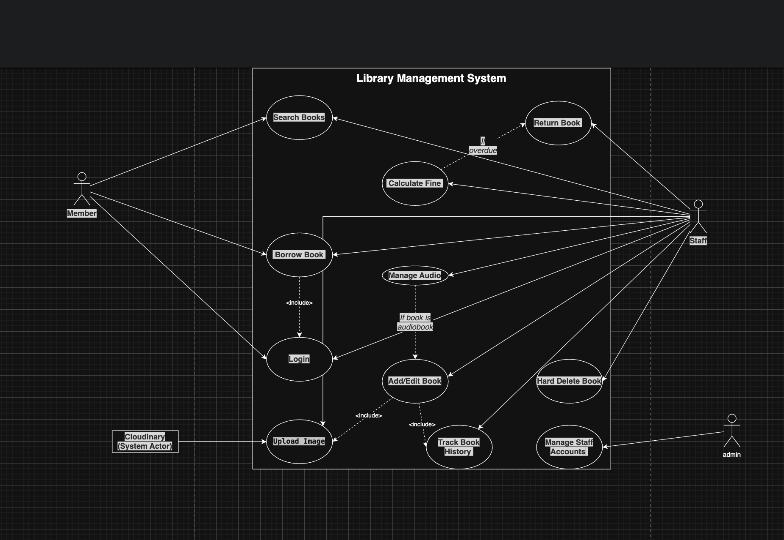

The Use Case diagram describes the interactions between four primary actors in the Library Management System:
- Member (Reader): Performs book catalog lookups and online borrowing requests.
- Staff: Responsible for managing the book repository, including adding, editing, deleting, uploading cover images, and managing audio files. This actor also handles the returning process. The Calculate Fine function is an <<extend>> relationship from the returning process, triggered only when a book is overdue.
- Admin: Inherits all permissions from the Staff actor and possesses additional authority to manage staff accounts.
- Cloudinary (System Actor): Acts as an external storage service, invoked by the system whenever the "Upload Image" or "Upload Audio" functions are executed.
  - C4 MODEL
DIAGRAM 1: C4 level 1 – Context Diagram
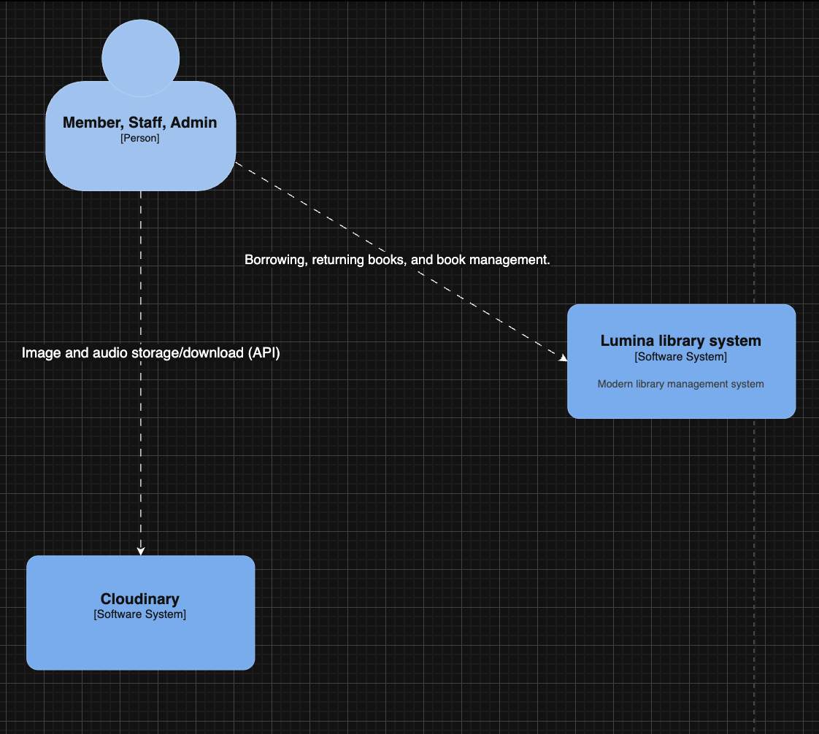

System Context Diagram (C4 Model - Context Level)
The System Context Diagram provides the highest-level overview of the Lumina Library system. It illustrates the primary users (Actors), the core software system, and the data communication flows with external third-party services.

1. Actors
In this diagram, user groups are represented as Actor entities who interact directly with the software. These are categorized into three roles with distinct data access levels:
- Member (Reader): End-users who use the system to browse the catalog, view personal history, and perform borrowing/returning processes.
- Staff (Librarian): Operational staff who interact with the system to manage the book inventory, create/approve loan slips, handle book returns, and process fines.
- Admin (Administrator): High-level users who manage all system data, provision staff accounts, and monitor statistical reports.

2. Main Context (Software System)
- Lumina Library System: The central software system developed for this project (comprising both the Web Frontend and Backend API). This core system is responsible for all business logic, including: book catalog management, tracking borrowing/returning workflows, calculating inventory status, and processing fines.

3. External Systems
- Cloudinary: A third-party Cloud-based Media Management platform.

4. Data Flows & Interactions
- Between Actors and Lumina Library System: A bi-directional data flow. Users send business requests (HTTP/JSON Requests) such as adding books or requesting loans. The system processes these requests, updates the internal database state, and returns the results (Web Interface/JSON Data).
- Integration with Cloudinary (Image/Audio API): A media data flow. When users (Staff/Admin) upload book covers or audiobook files via the interface, the system utilizes API protocols to stream the data directly to Cloudinary’s servers. Conversely, during searches, Cloudinary returns media URLs to be displayed to the Member. This integration reduces bandwidth load and storage requirements for the main Lumina server.

DIAGRAM 2: Container Diagram
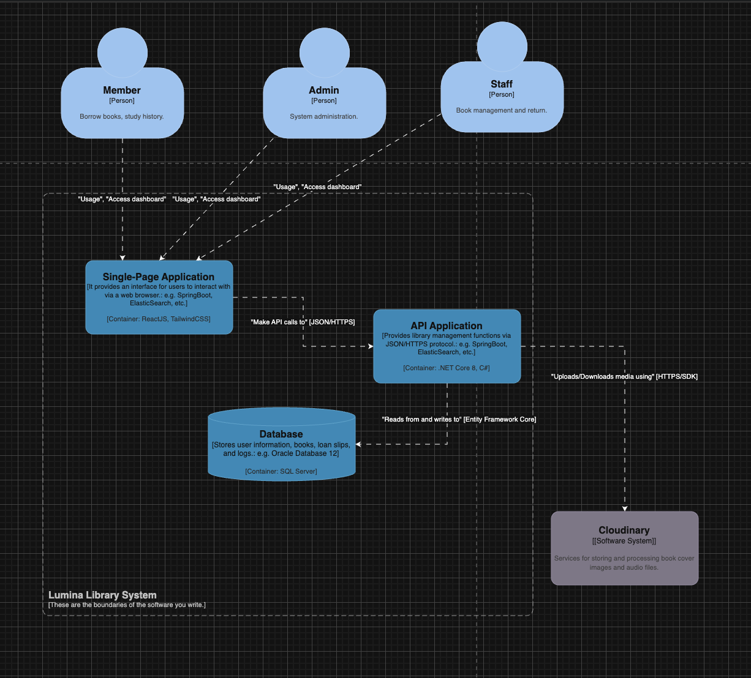

Container Diagram (C4 Model - Container Level)
The Container Diagram delves into the technical details of the Lumina Library system, illustrating the specific applications, services, and data stores, along with the technologies used to build them.

1. Architectural Overview
The system is designed following a decoupled Client-Server model, comprising three primary containers within the system boundary:
- Single-Page Application (Frontend): The user interface.
- API Application (Backend): The central business logic processor.
- Database: The relational data store.

2. Detailed Container Analysis

Single-Page Application (Web App)
- Technology: ReactJS, Tailwind CSS.
- Role: This is the primary touchpoint for all users (Member, Staff, Admin). This container is responsible for rendering the User Interface (UI), managing the User Experience (UX), and dispatching HTTP requests to the Backend. The application runs directly within the user's web browser.

API Application (Backend API)
- Technology: .NET 8, C# (ASP.NET Core Web API).
- Role: Acts as the "brain" of the system. This container provides RESTful APIs for the Frontend to consume. It executes all core business functions, including User Authentication (Auth), book inventory checks, fine calculations, and processing borrowing/returning transactions.
- Communication: Receives JSON requests from the Frontend and communicates with the Database via an ORM.

Database
- Technology: Microsoft SQL Server.
- Role: Provides persistent storage for all structured system data, including tables for Users, Books, Borrow Slips, Borrow Details, and Fine records.

3. Interaction with External Systems

Cloudinary
- Role: A Cloud Storage service used to host unstructured data, such as book cover images and audiobook files.
- Benefits: Decoupling media storage from the primary database reduces the load on SQL Server and improves page load speeds by leveraging Cloudinary’s Content Delivery Network (CDN).

4. Communication Protocols & Data Flow
- User Frontend: Users interact via the web interface over HTTPS.
- Frontend Backend: Communication occurs via HTTPS using JSON as the data exchange format.
- Backend Database: The Backend connects and queries data using Entity Framework Core (EF Core)—an ORM that ensures secure and efficient interaction with SQL Server.
- Backend Cloudinary: The Backend utilizes the Cloudinary SDK over HTTPS to perform upload tasks and retrieve media resource URLs.

DIAGARM 3: C4 level 3 – Componet Diagram (Backend API)
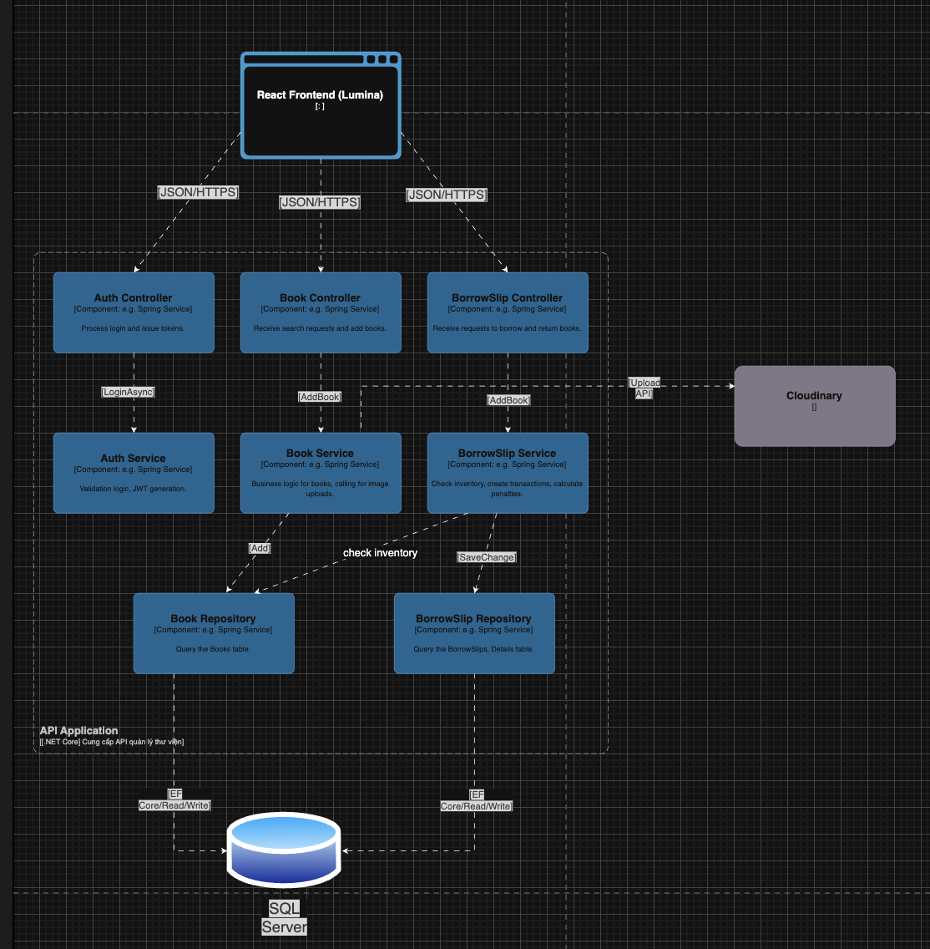

Component Diagram (C4 Model - Component Level)
The Component Diagram breaks down the internal structure of the API Application, illustrating how the source code is organized into a Layered Architecture and how individual components interact to execute business functions.

1. Presentation Layer (Controllers)
This layer serves as the entry point for HTTP requests sent from the React Frontend.
- AuthController: Handles login and registration requests. It delegates authentication logic to the AuthService.
- BookController: Manages requests for searching and adding new books. It is responsible for initial data validation.
- BorrowSlipController: Handles book borrowing and returning requests. It ensures the correct HTTP status codes (200, 400, 500) are returned to the client.

2. Business Logic Layer (Services)
This layer contains the "heart" of the system's logic and business rules.
- AuthService: Executes password hashing, account verification, and JWT (JSON Web Token) generation.
- BookService: Manages the logic for adding books. This component interacts with the Cloudinary API to upload book covers before saving the metadata to the database.
- BorrowSlipService: The most complex component. It orchestrates the borrowing workflow:
  - Verifying inventory availability.
  - Initiating database transactions.
  - Calculating due dates and potential fines.
  - Coordinating the persistence of the borrow slip.

3. Data Access Layer (Repositories)
This layer interacts directly with the database using Entity Framework Core.
- BookRepository: Provides CRUD (Create, Read, Update, Delete) methods for the Books table.
  - Note: This repository is cross-referenced by the BorrowSlipService to perform inventory checks.
- BorrowSlipRepository: Manages the persistence of BorrowSlip and BorrowDetail records.

4. Typical Interaction Flow (Example: Borrowing a Book)
To illustrate how these components work together, here is the sequence for a Borrow Book request:
- React Frontend sends a JSON borrowing request to the BorrowSlipController.
- The Controller validates the request format and passes the data to the BorrowSlipService.
- The Service performs an inventory check by calling methods within the BookRepository.
- If the book is available, the Service instructs the BorrowSlipRepository to save the new record.
- The Repository executes the SaveChanges command to persist the data into SQL Server.
  - Layered Monolith
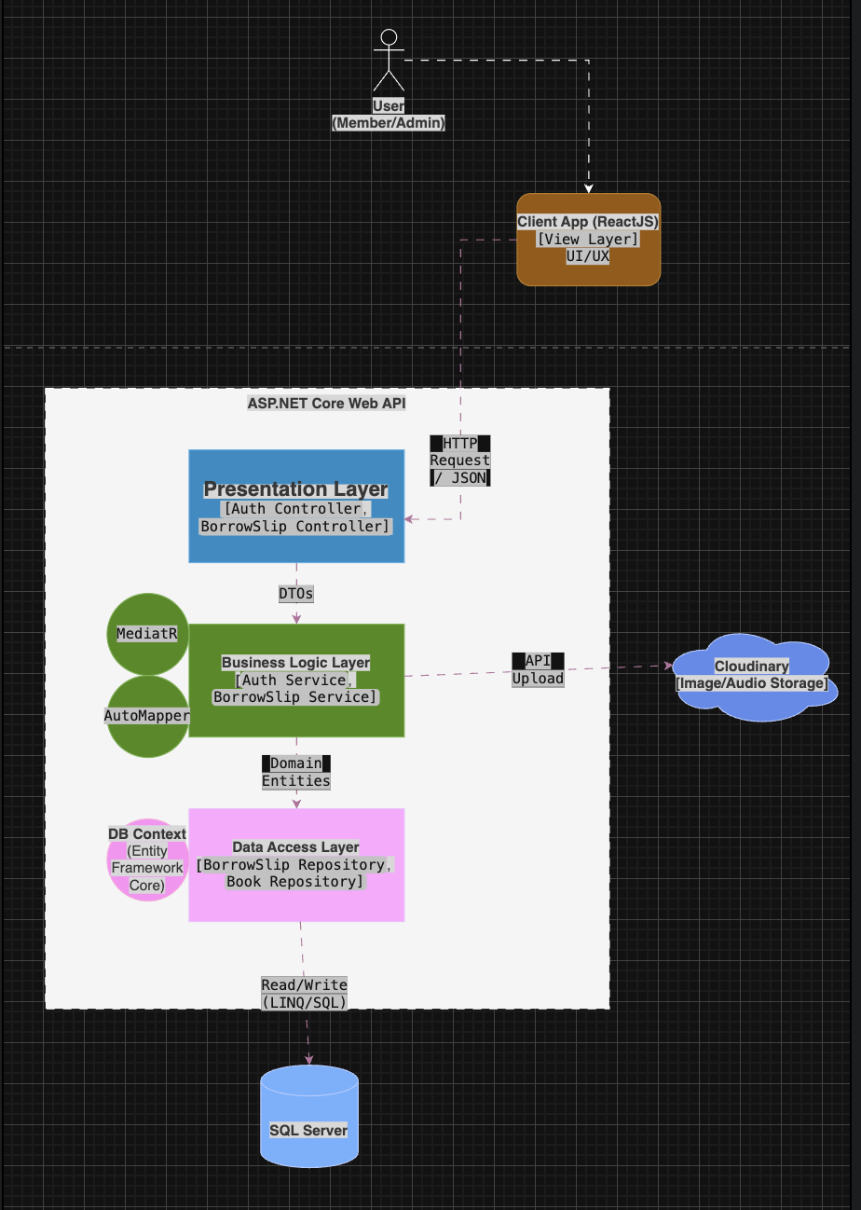
This section provides a technical deep dive into the overall architecture of your project. Here is the professional English translation, utilizing standard industry terminology for .NET 8 development.

System Architecture
The Lumina Library project is built on a Layered Monolith architecture. This is a widely adopted architectural pattern for .NET Core applications, ensuring the principle of Separation of Concerns (SoC), which makes the system maintainable, testable, and scalable.
The system is organized into a 3-Tier Architecture, with data flowing top-down through three primary layers:

1. Presentation Layer
- Components: Controllers (e.g., AuthController, BorrowSlipController).
- Responsibilities:
  - Serves as the Entry Point for the Backend API.
  - Receives incoming HTTP Requests from the Client App (ReactJS) in JSON format.
  - Handles Authentication and performs initial Input Validation.
  - This layer contains no business logic; its sole purpose is to orchestrate data movement to the layer below.

2. Business Logic Layer (BLL)
- Components: Services (e.g., AuthService, BorrowSlipService).
- Responsibilities:
  - Acts as the central "brain," processing all system business rules (e.g., verifying book inventory before a loan or calculating overdue fines).
  - Transaction Management: Ensures data integrity when performing multiple simultaneous write/delete operations.
  - Integration: Communicates with external APIs (Cloudinary) for image and audio file storage.
- Supporting Technologies:
  - AutoMapper: Used for automated data mapping between DTOs (Data Transfer Objects) from the Controller and Domain Entities from the Database, reducing boilerplate code.
  - MediatR: Implements the Mediator pattern to handle Domain Events (internal system events), reducing direct coupling between services.

3. Data Access Layer (DAL)
- Components: Repositories (e.g., BorrowSlipRepository, BookRepository) and the DbContext.
- Responsibilities:
  - Interacts directly with the Microsoft SQL Server database.
  - Utilizes Entity Framework Core (ORM) to execute LINQ queries and CRUD (Create, Read, Update, Delete) operations.
  - Abstracts the complexity of SQL commands away from the business logic layer.

4. Data Flow
The processing of a typical request (e.g., Creating a Borrow Slip) follows this workflow:
- Client App sends an HTTP Request containing JSON data.
- The Presentation Layer receives the request, maps the data into a DTO, and passes it to the Service.
- The Business Logic Layer processes the business rules using Domain Entities. If media storage is required, it calls the Cloudinary API.
- The Data Access Layer receives the processed Entity and executes Read/Write commands to SQL Server.
- The result is passed back up through the layers to provide a final response to the user.

  - SOFTWARE TESTING
To ensure the stability, reliability, and correct operation of the Lumina Library system, the testing process is performed at two main levels: Unit Testing and Integration Testing. The application of a Layered Monolith architecture along with Dependency Injection techniques facilitates the isolation and testing of system components.
1. Testing Strategy
The system uses modern tools and techniques in the .NET Core environment to perform testing:
Testing Framework: Using xUnit, a popular and powerful testing framework for .NET.
Mocking Technique: Using the Moq library to simulate the behavior of the data access layer (Repository) and database (DbContext), helping to isolate business logic during unit testing.
Test Host Environment: Using an In-Memory Database (database in RAM) to perform integration testing without affecting real data on SQL Server.
2. Unit Testing
Objective:
Unit testing focuses on verifying the correctness of business logic processing functions in the Service Layer. The goal is to ensure that each smallest unit of code (methods) functions as designed when standing independently, not depending on external factors such as databases or third-party APIs.
Implementation Method:
Object Isolation: The object to be tested (e.g., BorrowSlipService) is initialized independently.
Mock Dependencies: Components that the Service depends on (such as IBorrowSlipRepository, IBookRepository) are replaced with mock objects.
Behavior Setup: Define the return value for the mock objects in advance (e.g., mocking whether a book is in stock or out of stock).
Assert Verification: Compare the actual return value from the function with the expected result.
Typical Test Scenarios (Case Studies):
Scenario 1: Handling book borrowing when data is valid.
Description: Simulate input data including valid reader ID and book ID, with the book's stock quantity greater than 0.
Expected Result: The processing function returns a successful borrowing slip object with the status "Borrowing", and the database storage function is called exactly once.
Scenario 2: Handling book borrowing when out of stock.
Description: Simulate a situation where the book inventory is zero in a dummy data warehouse.
Expected Result: The system should interrupt the processing flow and throw an exception with the message "Book is out of stock," ensuring no borrowing slips are created.
Scenario 3: Calculating Overdue Dates.
Description: Provide a return date that is a date in the past relative to the present time.
Expected Result: The system accurately calculates the difference in days and identifies this as an overdue case.
3. Integration Testing
Objective:
Integration testing aims to verify the interaction and data flow between the application layers: from Controller (receiving requests) to Service (processing logic), through Repository (retrieving data), and finally to Database. This ensures the API system functions correctly from end to end.
Methodology:
Initialize Virtual Server: Use WebApplicationFactory to create a simulated web server directly in memory.
Configure Virtual Database: Replace the actual SQL Server connection with an In-Memory database so that test data is automatically deleted after completion, ensuring a clean environment.
Send HTTP Requests: Create a simulated HTTP Client to send requests (POST, GET, PUT, DELETE) to API endpoints.
Test Response: Analyze HTTP status codes (200 OK, 400 Bad Request, etc.) and the returned JSON content.
Typical Test Scenarios:
Scenario 1: Create a borrowing slip via API.
Action: Send a POST request to the /api/borrow-slips path with complete reader and book information.
Expected Result: The API returns a 200 OK status code. The returned data contains the information of the newly created borrowing slip, including the Slip ID and Return Date. This data must be found when querying the virtual database again.
Scenario 2: Checking input data constraints.
Action: Send a POST request with an empty or missing list of books.
Expected result: The API returns a 400 Bad Request status code with a detailed error message, demonstrating that the Validation layer in the Controller is working effectively.
4. Summary of Test Cases
Below is a summary table of the important test cases performed to ensure the quality of the Book Borrowing/Returning functionality:
Successful book borrowing: Check the flow of creating a borrowing slip when the book is in stock and the reader is valid. The result is that the slip is created and the inventory is updated.
Failed book borrowing (Out of stock): Check the system prevents borrowing when the book inventory is zero.
Failed book borrowing (Reader does not exist): Check the integrity of the foreign key when an incorrect reader ID is entered.
Return books on time: Check the book return process when the actual return date is less than or equal to the scheduled date. The status of the return form changes to "Returned".
Return books late: Check the book return process when the actual return date is greater than the scheduled date.

CONCLUSION & FUTURE DEVELOPMENT

1. Lessons Learned
Through the process of building and deploying the Lumina Library management system, the team has gained significant insights into both technical implementation and the software development lifecycle:
- Mastering Layered Monolith Architecture:
  - We recognized the vital importance of separating the system into distinct layers (Presentation, Business, Data Access). This approach ensures clean code, eases maintenance, and prevents changes in one area from breaking logic elsewhere.
  - Successfully applied Dependency Injection (DI) in .NET Core to efficiently manage dependencies between classes.
- Data Handling & Transaction Techniques:
  - Gained a deep understanding of the role of Database Transactions in complex business operations (such as Book Borrowing). Ensuring Atomicity—the "all or nothing" principle—prevents data corruption (e.g., creating a borrow slip without its corresponding book details).
  - Mastered the use of DTOs (Data Transfer Objects) for data exchange between Frontend and Backend, effectively avoiding circular reference errors during JSON serialization and securing internal data structures.
- External System Integration:
  - Gained practical experience integrating third-party APIs (Cloudinary) to solve multimedia storage challenges (Images/Audio), significantly reducing the load on the primary database.
- Troubleshooting Skills:
  - Developed proficiency in debugging common web application issues, such as CORS errors, foreign key constraint violations, and managing asynchronous operations (Async/Await) between React and the API.

2. Future Improvements
While the current system meets core business requirements, the following enhancements are proposed to transform Lumina Library into a more robust, production-ready product:

Security Enhancements
- Password Encryption: Currently, the system performs direct comparisons. We aim to upgrade to secure hashing algorithms like BCrypt or Argon2 for storing passwords safely in the database.
- Refresh Tokens: Implement a Refresh Token mechanism to improve user experience, allowing secure session maintenance without forcing frequent re-logins when Access Tokens expire.

Functional Features
- Automated Email Notifications: Integrate email services (such as SendGrid or SMTP) to send automated reminders for upcoming due dates or digital receipts upon successful borrowing/returning.
- Online Payments: Integrate payment gateways (VNPAY/Momo) to allow readers to pay fines online instead of being restricted to cash payments at the counter.
- Review & Rating: Enable a community feature for readers to rate and comment on books.

Performance & Infrastructure
- Caching (Redis): Implement caching for static or infrequently changed data (e.g., book catalogs, categories) to reduce SQL Server load and accelerate API response times.
- Dockerization: Package the application (Backend + Frontend) into Docker Containers for seamless deployment across different server environments without configuration conflicts.

Architectural Evolution
- Clean Architecture: Should the system scale significantly, we will consider migrating from Layered Monolith to Clean Architecture (Onion Architecture). This would further decouple the Core Domain from infrastructure concerns, ensuring long-term sustainability.

